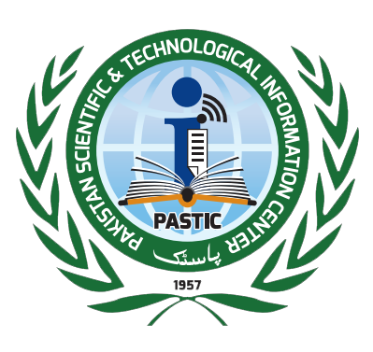

**Pakistan Scientific & Technological Information Centre (PASTIC)**

Quaid-e-Azam University Campus, Islamabad

P.O. Box: 1217, Islamabad

SITUATION VACANT

Applications are invited from Pakistani Nationals on prescribed format for the following positions on fixed pay in a development project “Modernization of PASTIC National Science Reference Library for effective Resource Sharing among S&T Libraries in Pakistan” on contract basis till 30th June, 2021 in Pakistan Scientific and Technological Information Centre (PASTIC), Quaid-i-Azam University Campus, Islamabad:

|  |  |  |  |  |  |
| --- | --- | --- | --- | --- | --- |
| **Sr.No** | **Name of Post and Monthly Salary** | **Age** | **No of posts** | **Quota** | **Qualification** |
|  | **Librarian for Liaison**  Rs.90000/-PM | 21-35 | 1 | Open Merit | MLIS having 3-years experience in the field of library management and have good expertise of noting drafting.  Proficiency in English language is essential. |
|  | **Web Developer**  Rs.90000/-PM | 21-35 | 1 | Open Merit | M.Sc. / BS (4 years) in Computer Science having 3-years experience in open source databases like PERL/CGI/PHP, MySQL etc. |
|  | **Network Administrator** Rs.90000/-PM | 21-35 | 1 | Open Merit | M.Sc / BS (4 years) in Computer Science / IT recognized by HEC with 3-years experience in LAN & WAN design, implementation and maintenance. Certification in Network Administration shall be preferred. |
|  | **Assistant Librarian** Traditional Library  Rs.60,000/-PM | 21-35 | 1 | Open Merit | MLIS with no experience/ BLIS with 3 years experience of cataloguing and classification of books in a library of Government/ Semi-Government/ Autonomous or in Private organization. |

## The prescribed format of the application has been placed at the PASTIC website ([www.pastic.gov.pk](http://www.pastic.gov.pk))

## Degree /Certificates obtained from HEC/Govt. recognized institution will be accepted

## The selected candidate will be posted anywhere in Pakistan

## Candidates already in service should apply through proper channel

## The relaxation in age limit will be allowed as per government rules

## PASTIC/PSF reserve the right to stop the recruitment process at any stage

## The decision of PASTIC/PSF shall remain binding in all cases

## No.TA/DA will be paid for appearing in test/Interview

## PASTIC/PSF reserves the right to call shortlisted candidates for test/interview.

## Any kind of direct or indirect canvassing would result in instant disqualification any stage of selection

## Application submitted by hand will not be entertained

## Applications on prescribed format duly enclosed in envelope and clearly name of the post on envelop may reach to Additional Director (Admin), PASTIC, Quaid-i-Azam University, Campus, Islamabad within 15 days of publication of the advertisement. The Incomplete applications or received after the due date shall not be entertained.

## (MUHAMMAD GHAZI JAKHRANI)

## Additional Director (Admin

**Tel: 051-9248105**